(Approx. 764 words)

Mastering Line and Paragraph Spacing in Word
By Nancy DeMarte, 1st Vice President, Sarasota Technology User Group, Florida
December 2017 issue, Sarasota Monitor
www.thestug.org
ndemarte (at) verison.net

If you are a long time Word user, you probably have had at least one bad experience with setting the space between lines of text or paragraphs. Maybe you began typing a document and found that the space had increased mysteriously from your last document. Or when you tried to copy a paragraph from one document to another, the line spacing changed during the transition. Microsoft must have heard the complaints, because in recent versions of Word, the tools for managing spacing have increased and improved.

In Word version 2003 and earlier, the Normal or default style properties were Times New Roman font, size 12 points (Points are based on font height.), left justified, with no space between lines or before paragraphs, and 4 points after paragraphs. Beginning with version 2007, however, a new Normal style was introduced which had a different font and smaller font size. (See chart below) Many users had problems with this change. The smaller-sized font was hard to see. The extra space between lines and paragraphs reduced the amount of text that a page could hold. In response to the concerns, Microsoft made another change beginning with Word 2013. This version reduced the space between lines to 1.08 and the space after paragraphs to 8 points, as shown in the chart.
Word Version | Body font & size in points | Points between lines | Points before paragraphs | Points after paragraphs
2003 | Times New Roman 12 | 0 (single-spaced) | 0 | 4
2007, 2010 | Calibri 11 | 1.15 | 0 | 10
2013, 2016 | Calibri 12 | 1.08 | 0 | 8

To meet the continuing needs of Word users, Word 2016 offers several choices of tools to help users set up their own spacing settings. Five of them are described below:

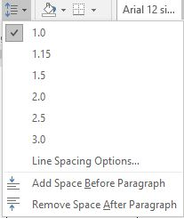
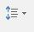
1. Beginning with Word 2007, a Line and Paragraph spacing icon was added to the Paragraph group on the Home tab. This tool lets you make manual changes to the spacing of selected text or whole documents. When clicked, the menu offers several pre-set line spacing amounts as well as Line Spacing Options, where a precise number of points between lines can be set. This tool also gives a quick, one-click way to add or remove space after or before paragraphs.
Line and Paragraph Spacing tool menu

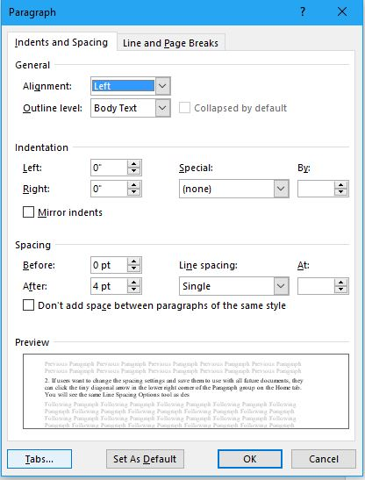
2. If you want to change the spacing settings and save them to use with all future documents, you can click the tiny diagonal arrow in the lower right corner of the Paragraph group on the Home tab to open the Paragraph dialog box. Choose spacing options using the dropdown menus, then click the “Set as Default” button, and then the button to save these changes for the current document only or for all future documents. Then click OK. All new documents will have that spacing pattern until you change it.

Paragraph group Dialog box

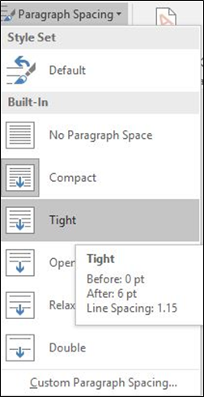
3. In this fast-moving age, it isn’t surprising to find new tools which let you create both line and paragraph space settings with a single click. You will find a tool, called Paragraph Spacing, on the Design tab, which is a new tab in Word 2016. It offers a few choices, each of which includes a setting for spacing before and after paragraphs and another for space between lines. Hovering your mouse pointer over one of the options reveals its exact settings, as shown.
Spacing Style Sets in Word 2016

4. The Design tab offers another new feature which lets you choose a Style Set to apply to a whole document. Style Sets contain all the style elements: Fonts and font sizes for titles, headings, and body text, as well as line and paragraph spacing. By opening a document and moving your mouse pointer over the choices, you can preview how they would affect your document. Notice that among the style sets are Office 2003 and 2010.
If you want to make your chosen Style Set your permanent style, click the “Set as Default” arrow in the green circle to the right of the Style Sets.

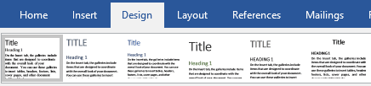
Figure 1 Document Style Sets on the Design tab (Word 2016)

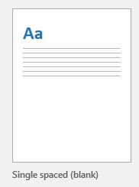
5. If all you really want to do is to return to the basic, single-spaced Word format, Microsoft recently added a single-spaced template. You will find it in the top row of the first screen you see when you open a new Word 2013 or 2016 document.

The more we eliminate the little annoyances in applications, the smoother our computing will be.

